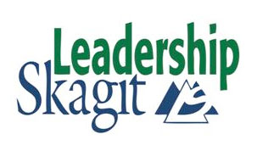

Skagit County has allocated limited annual funding to sponsor employee participation in Leadership Skagit.

TUITION REQUEST
Date: Department:

Employee: Job Title:

Application for the Class of:
Tuition:

What portion of the tuition are you paying? ☐ 10% ☐ Other % = $

What portion of the tuition are you requesting? % = $
What portion of the tuition is in your department’s budget? % = $
Time Commitment – This class will have some impact on the employee’s work schedule, there are at least ten full work days scheduled during this class:
Acknowledgement: (Employee initials) (Dept. Head/Elected Official initials)
Benefits to be derived from attending class for Skagit County:

APPROVED:

Date:
Department Head/Elected Official Approval

Date:
County Administrator Approval

